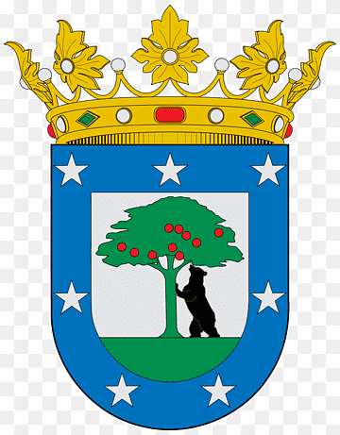
Madrid Quiz
- 1 point for a photo taken in each location (at least two members of your group must be in each photo). Bonus points available for original/creative poses!
- 1 point for each question answered correctly.

1.Plaza Mayor
The Plaza Mayor was once the centre of old Madrid. It was completed in 1620 and in the past was used for many purposes, including bullfights, processions, fiestas and theatrical productions, trials of the Inquisition, and even executions.
Whose statue is located at the centre of this square?
The square has burned down three times in its history. Look at the circular benches to see the metal engraving of the last fire as well as other historical moments from its past.

2.Restaurante Botin
The restaurant Botin is the oldest restaurant in the world and is a common destination for tourists. Their speciality is suckling pig cooked in the same oven that was used when the restaurant first opened.
What year did the restaurant open?
Legend has it that Goya worked in the kitchens of the restaurant in 1765 when he was waiting to be accepted as a student at the Royal Academy of Fine Arts.

3.Plaza de la Villa
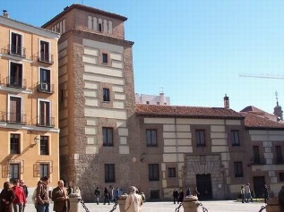
This square has some of the oldest buildings in the city and was one of the main medieval centres of Madrid.
The oldest building is thought to be the tower of the Lujanes. The legend of this tower is that King Francis I of France was kept captive here in 1525 after losing in battle to Carlos I. When Francis I refused to bow to Carlos I, the king of Spain had the entrance doorway lowered so that Francis was forced to bow every time he left or entered the building.
What organisation is now located at No 2 Plaza de la Villa?
4.Almudena cathedral
Building work on the Almudena cathedral started in 1893, but it was not completed until 1993. One of the reasons for this delay was the civil war in the 1930s.
If you walk north past the main cathedral entrance, you will see a square on your left. On your right you have the back of the palace, and to your left you have the cathedral de Almudena.
Find the entrance to the cathedral museum on this square. What are its normal opening hours?
*If you walk to the far side of this square, between the palace and the cathedral, you can see one of the best views in Madrid. Take a minute to look out at the Casa de Campo, the largest public park in Madrid, and the mountains to the west of the city.

5.The Royal Palace
The Royal Palace of Madrid is the largest in Western Europe and one of the largest in the world. It was built by Carlos V, the first king in the Bourbon dynasty (the same as the current Spanish Royal family. With over 135,000 square metres and 3,418 rooms, it has witnessed centuries of Spanish history.
Outside the palace there is a plaque commemorating heroes from ‘2 de mayo de 1808’ What happened here on this date? (You can use your phone to look this up, or to translate the plaque.)
The previous palace was destroyed in a fire in 1734 and most of the artwork at the Prado from pre 1734 survived this fire. The servants cut the paintings from the frames and threw them out of the windows!

6.Plaza de Oriente
From Plaza de Oriente you can see the palace and the Royal Opera House. The man on the statue is Philip IV. When he ordered the statue to be constructed, he wanted the horse to be rearing, which was very unusual for the time. The Italian sculptor Tacca couldn’t think of a way to achieve this (so that the statue wouldn’t fall over), so he wrote to Galileo Galilei for help.
Galileo solved the problem, but how? Look carefully at the base of the statue.

7.San Gines chocolateria
A traditional snack in Madrid is a cup of hot chocolate with churros (a type of long doughnut).
Cacao was brought back to Spain from South America in the 16th century. People then adapted it by adding sugar and cinnamon. By the 17th century thick, hot chocolate was very popular with the Spanish elite and then later with the general public.
The San Gines chocolateria is one of the most famous places to try this. If you have time to spare you could try some!
When did the chocolatería open?

8.Sol
The Puerta del Sol (gate of the sun) is one of the most famous squares in Madrid and is a common meeting place for both tourists and residents. In the centre is a statue of Carlos III. The large white building was built in the 18th century and was built as Madrid’s central post office.
Since the 1990s it has been the headquarters of Madrid’s regional government.
The bear and strawberry tree statue represents the Madrid coat of arms. Medieval Madrid had lots of forests and bears were very common. The ‘strawberry’ tree is in fact an unedo tree. This is a tree which is common to Spain and Portugal and has small red fruits which can be used to make liqueur.
Which parts of the bear are gold?

Bonus challenges
Sol is the point from which all Spanish roads are measured. Where is the ‘km 0’ plaque located? Take a photo of the plaque, which shows the very centre of Madrid, to receive 2 extra points!
Madrid is famous for its ‘bocadillo de calamares’ (squid sandwiches). Find a café or restaurant which has a picture of this dish on its menu and take a picture for 2 extra points!

Summary:
8 location picture opportunities
8 questions to answer
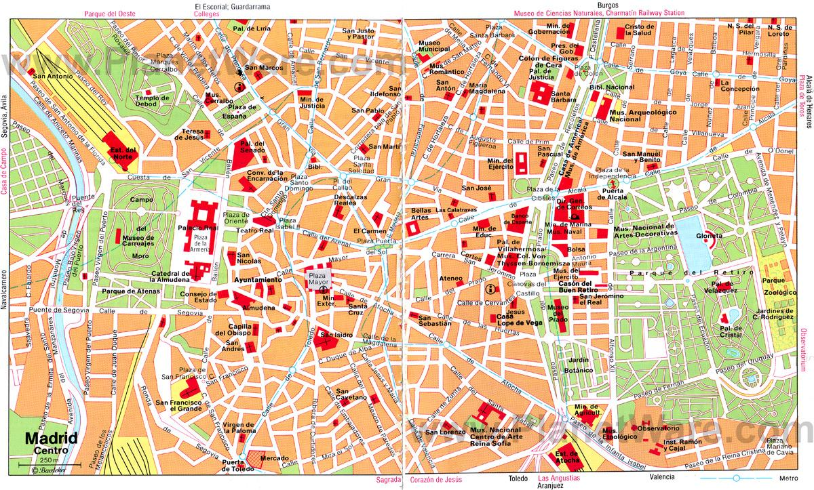
4 bonus points available

